TASK 4: Setup and use firewall on windows

Objective:

Configure and test basic firewall rules to allow or block traffic

Step1:

* Open windows firewall defender if you are using windows
* You will be able to see inbound and outbound rules

Inbound rules:

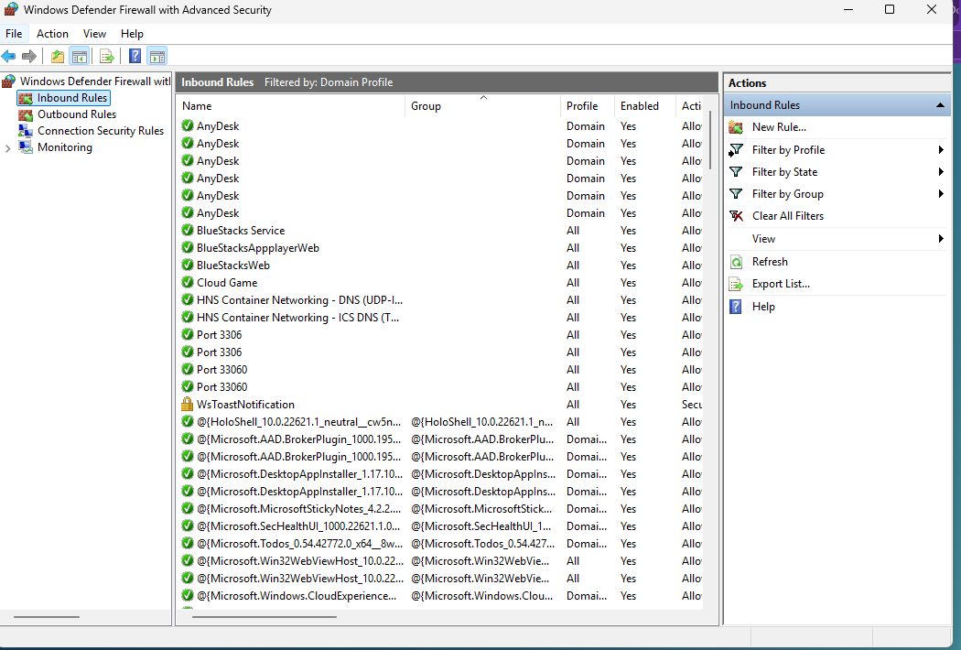

Outbound rules:

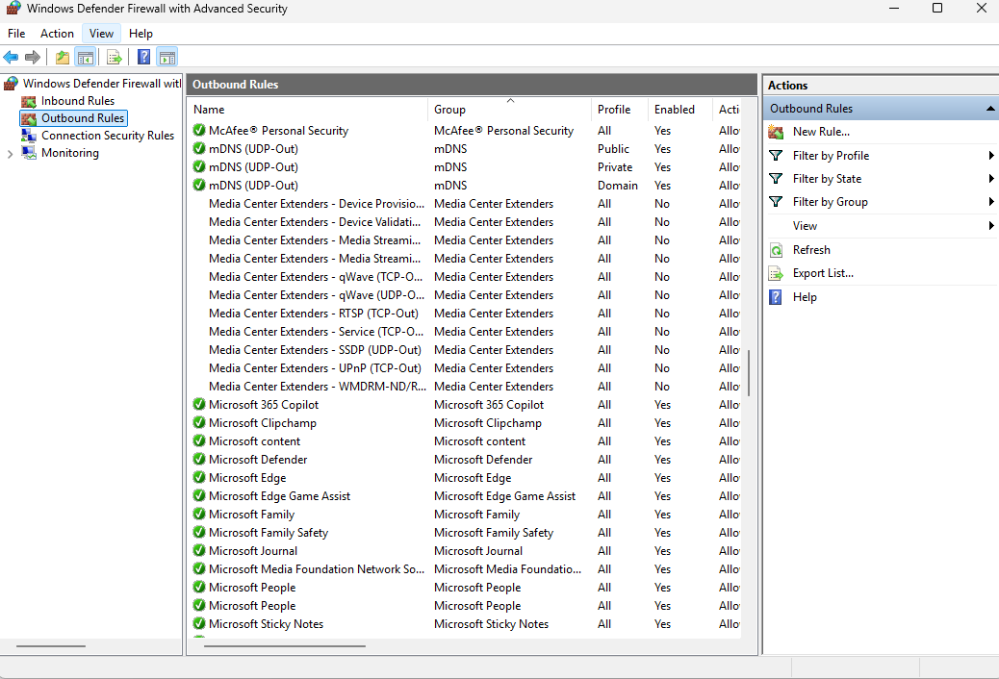

Step 2:

* Create a rule to block a port which you like
* Here I am blocking the port https(port 443)

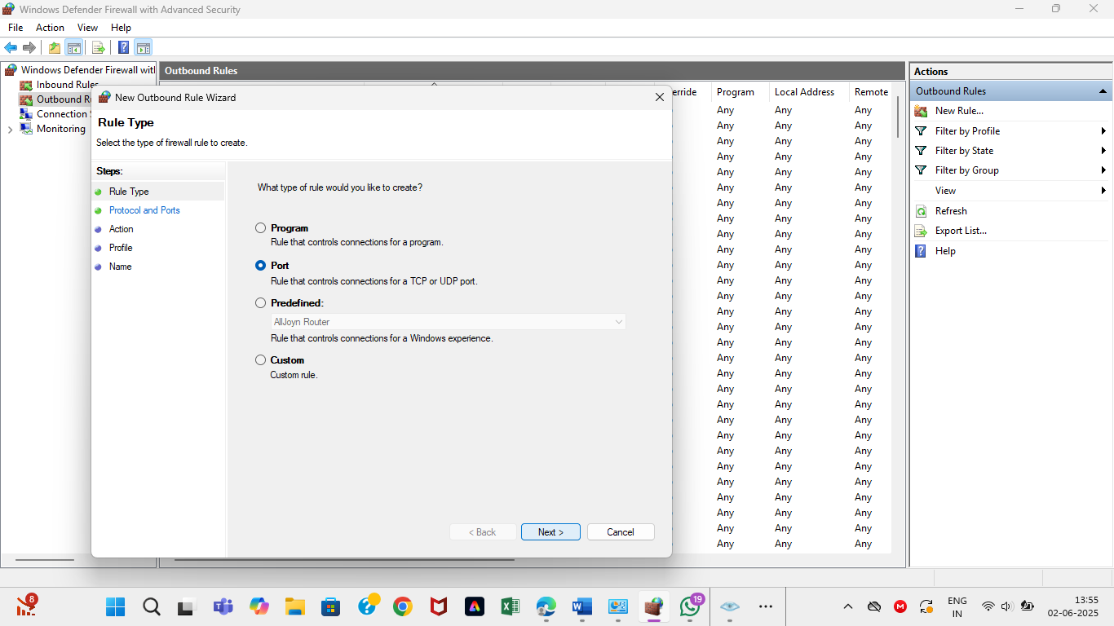

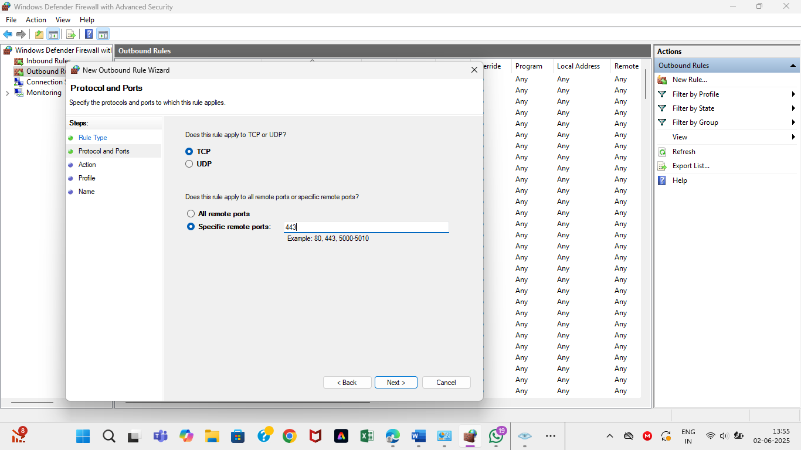

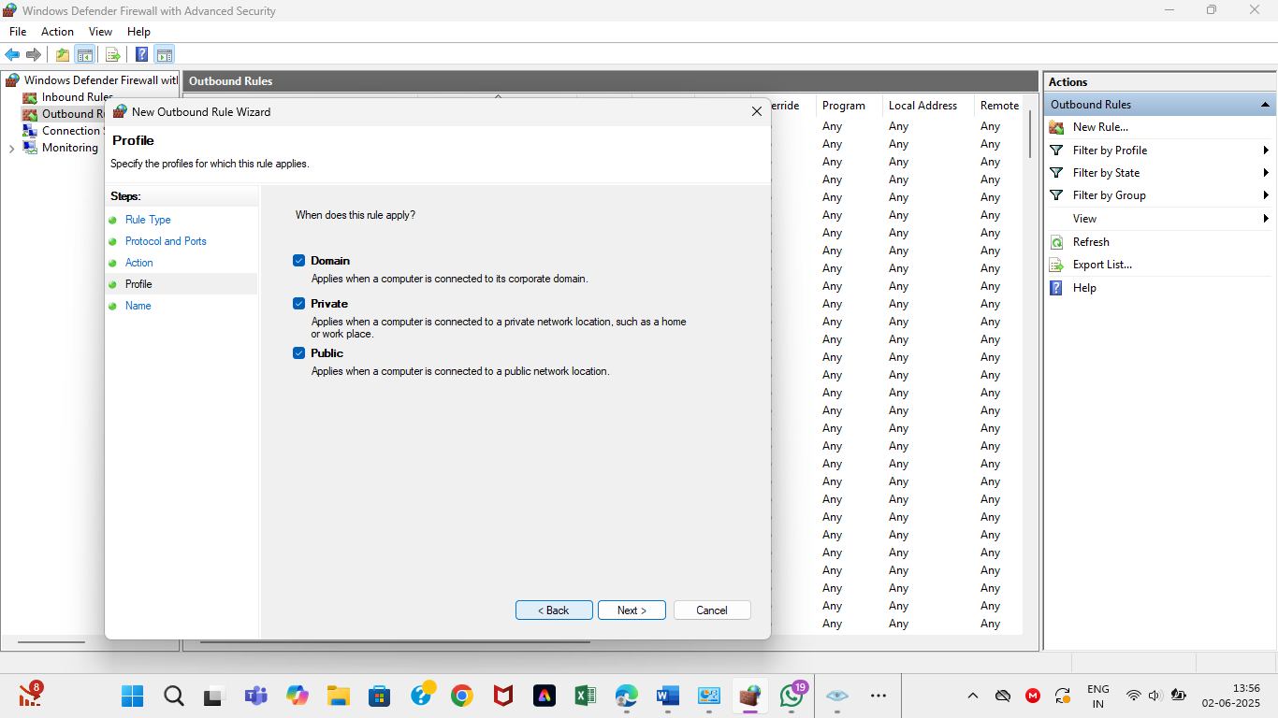

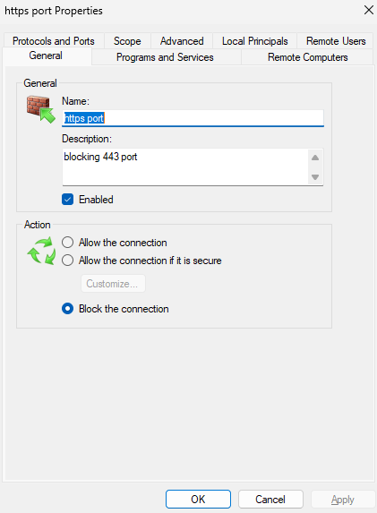

Output: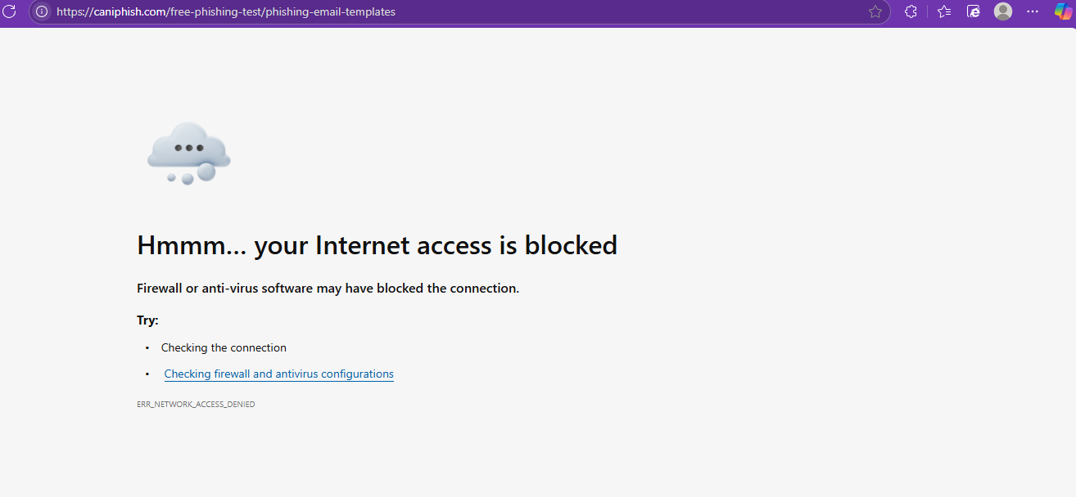

Step 3:

DELETING THE RULE:

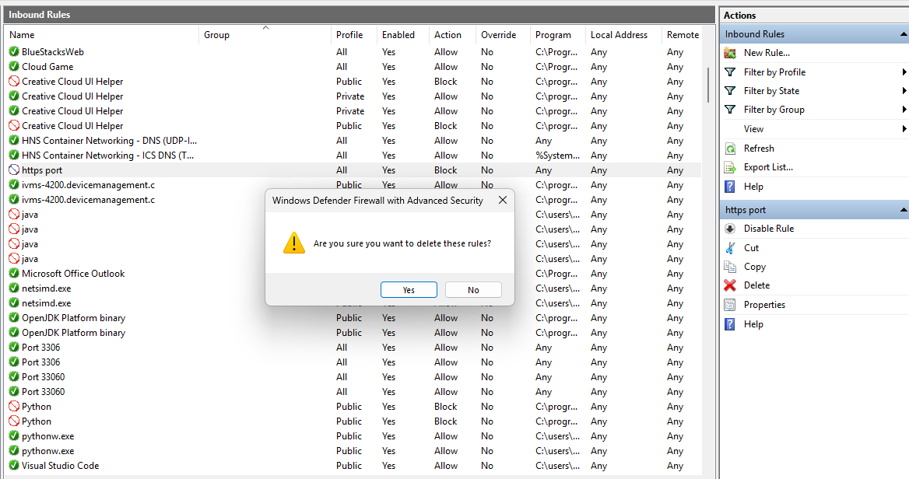

* After deleting the rule,the site can be accessed through the browser

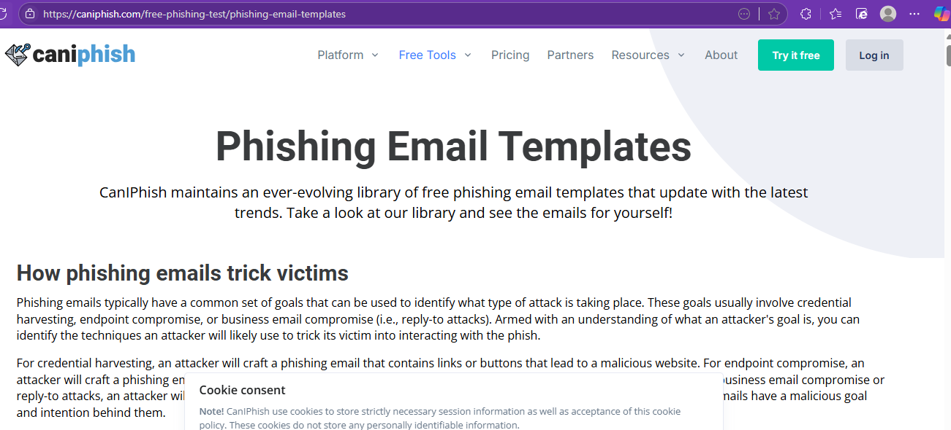

Nmap scan :

